CSD3156 Lab9 Report

Student Name: Bryan Ang Wei Ze
Student ID: 2301397

Result 1: Please paste the screenshot in the box below.
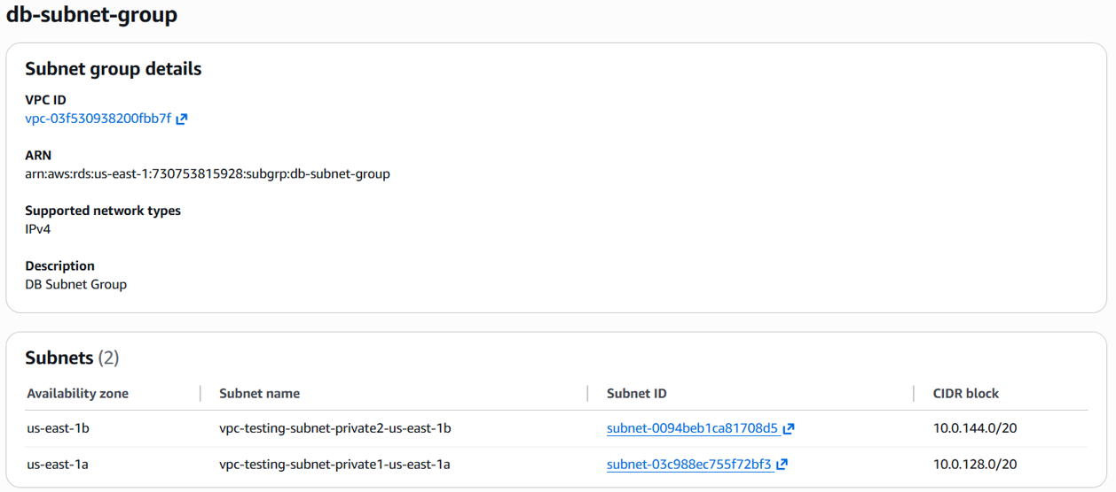

Result 2: Please paste the screenshot in the box below.
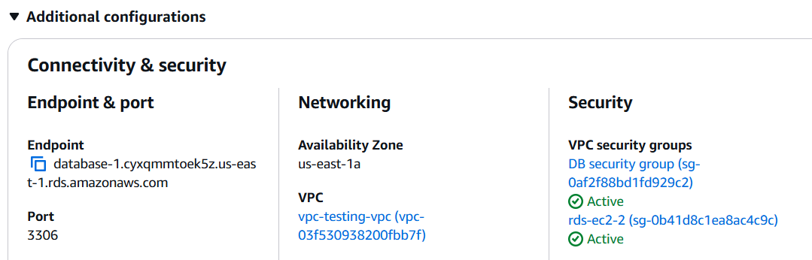

Result 3: Please paste the screenshot in the box below.
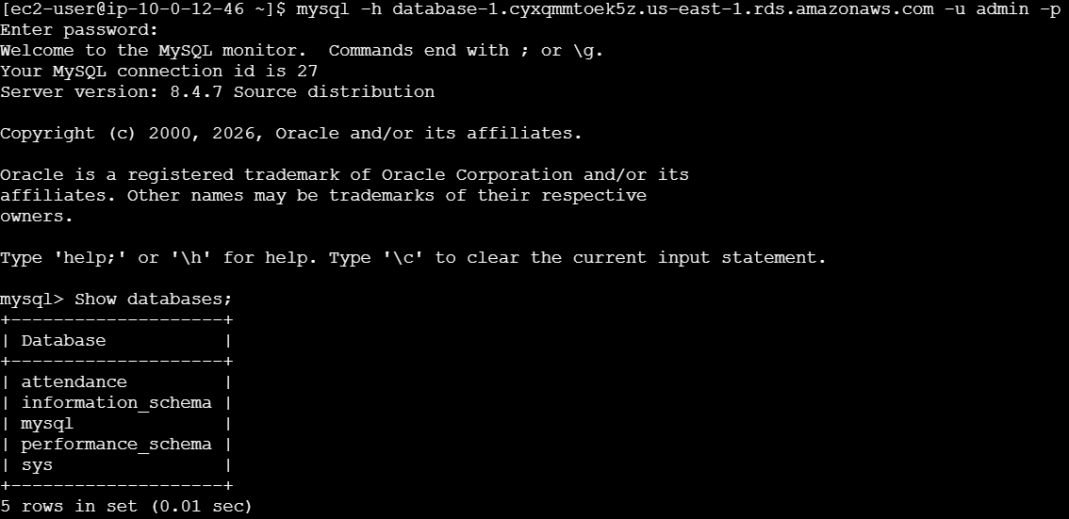

Result 4: Please paste the screenshot in the box below.
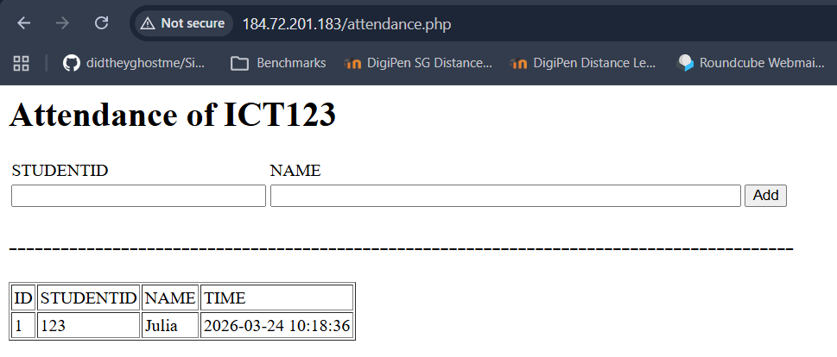

Result 5: Please paste the screenshot in the box below.
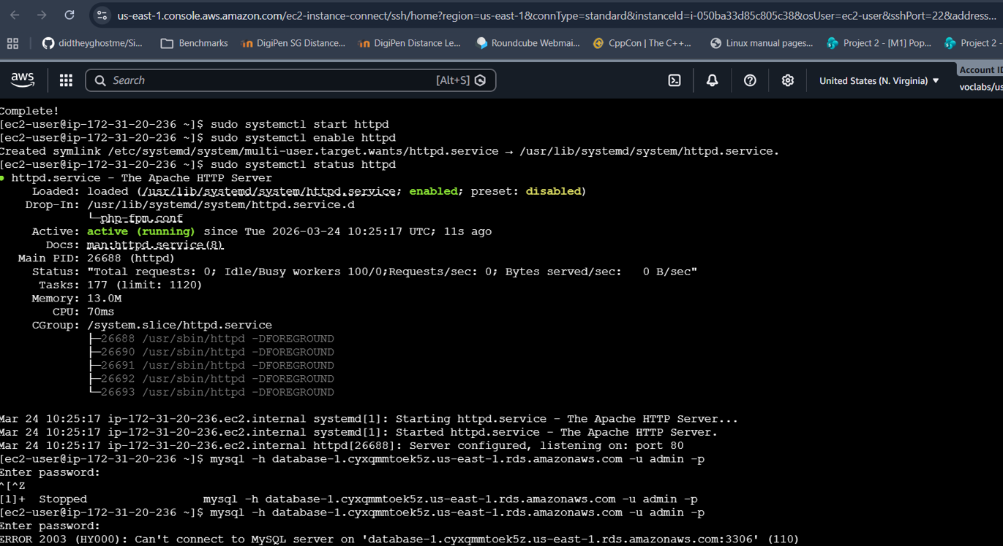

Reflection: Please add one or two lines on what you have learned.
I learnt how to configure a secure VPC with subnets and security groups and deploy a web application on EC2 connected to an RDS database for secure data access.

